Keywords

Summary

References
Masterplan WTI-2017. Deltares report: 1201617

Version | Date | Author | Initials | Review | Initials | Approval | Initials
0.1 | Aug 2012 | R Brinkman
State
draft
This is a draft report, intended for discussion purposes only. No part of this report may be relied upon by either principals or third parties.

Contents
1.1 RTO A-1
1.2 Background A-1
1.2.1 WTI-2017 project A-1
1.2.2 Assessment method according to the RTO-2017 A-3
1.2.3 Global Assessment Work flow A-5
1.2.4 Stakeholders and users A-6
1.3 Failure mechanisms A-7
2.1 Over all architecture A-9
2.2 Failure mechanism considerations A-10
2.3 Failure mechanism design A-11
2.4 User interface design A-15
Appendices
A Glossary of terms A-19
B Data classes B-24

Introduction

RTO

RTO is a software system for safety assessment of the primary Dutch flood defence systems (dike rings), according to new Dutch regulations called RTO-2017 (Voorschriften Toetsen op Veiligheid). RTO consists of the following parts:

- Database containing hydraulic and water defence related data, such as water levels and dike characteristics
- HydraRing, a software component which calculates the dike safety in a probabilistic way
- Ringtoets, the user interface for HydraRing
- Failure mechanism library. A failure mechanism calculates dike failure for a single physical aspect in a deterministic way
- RTO UI-tools. A set of user interfaces for the failure mechanisms (one UI-tool per failure mechanism)

The latter two RTO parts, i.e. the failure mechanism library and the RTO UI-tools, are called the RTO-tools. There are multiple failure mechanisms, such as overtopping and revetment, and as a result there will be multiple RTO-tools.

This is the technical design document for the RTO-tool Overtopping. This document describes the softare architecture of the RTO UI-tools. It elaborates the relations and the key interfaces between the failure mechanism libaries, the dike strenght software (like Ringtoets [Lit. 1]) and the RTO UI-Tools. The required data conversion between the (complex) data classes and the (simple) Fortran variables is also part of the interface description. This document explaines both the general RTO UI-Tools architecture and the RTO-tool Overtopping specific architecture. The functional design of the failure mechanism Overtopping (e.g. the computation core) is documented in [lit.2] and the functional design (and requirements) of the User Interface of the RTO UI-Tool Overtopping is documented in [Lit.3].

------------------
Lit. 1: Ringtoets Requirements and Design
Lit. 2: Functional Design Overtopping Mechanism.
Lit. 3: Functional Design UI-Tool Overtopping

Background

WTI-2017 project

Rijkswaterstaat has commissioned Deltares to develop a new set of methods and tools for assessing and designing the Dutch flood defence systems based on the failure probability of a dike ring. Since 2012, this development is a part of the project WTI-2017. A first version of the new regulations and supporting software needs to be available in the course of 2013, in order to start an evaluation and improvement period that will run until the end of 2016.

2009
TOI: Preliminary development
WTI-2017: further development and evaluation
2011
2016
New instruments

Figure 1.1 Global time schedule TOI project

Figure 1.2 presents a sketch of the view of Rijkswaterstaat on the context of the assessment instruments.
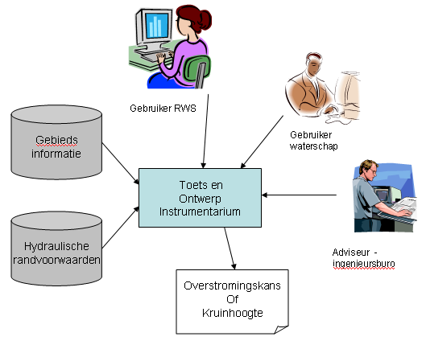
Figure 1.2 Rijkswaterstaat view on system context

Figure 1.3 shows the shared failure mechanism and UI libaries for WTI dike assessing and designing tools. The mechanism Overtopping is the failure mechanism decribed in this report. Shared libraries allow for generic tool development and implementation, which fits into the Rijkswaterstaat’s vision to optimize the total support and maintenance costs of software applications.

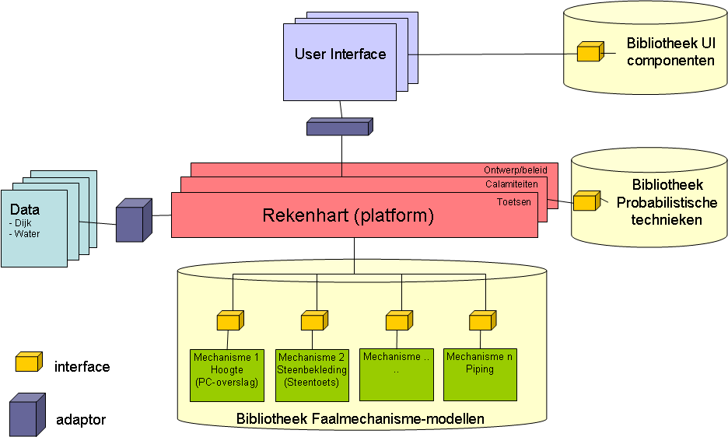

Figure 1.3 Shared libaries for WTI dike assessement and designing tools

Assessment method according to the RTO-2017

The current set of regulations (RTO-2006) and supporting set of software (Hydra’s, Steentoets, Grastoets, Golfklap, D-GeoStability/MStab, Duros etc) is based on a partly probabilistic and partly deterministic safety assessment of dikes, dunes and structures. The Hydra software determines first in a probabilistic fashion the water level, wave parameters and overtopping characteristics per cross section. Further assessment for other failure modes (mechanisms) is executed per failure mode and per section, using a characteristic water level with allowed exceedance frequency (toetspeil) as calculated by the Hydra’s. After an initial relevance check (level 0), a simple assessment by a decision rule (level 1) can be followed by a detailed assessment (level 2). The simple assessment usually requires only the geometrical properties to be known, whereas a detailed assessment usually requires additional physical model parameters. This deterministic method is also called semi-probabilistic, because prescribed partial safety factors implicitly ensure that the annual failure probability stays always below an allowed value per section and mechanism.

The new RTO-2017 regulations will also support this RTO-2011 type deterministic assessment per mechanism and section. Part of the TOI project will therefore aim at the calibration of the safety factors for the final RTO-2017 mechanism models in 2017. Additionally, the new RTO-2017 regulations and supporting software will allow an explicit probabilistic assessment, taking into account the combined contributions from different failure modes and different sections. The prescribed failure mechanism models for detailed probabilistic and semi-probabilistic analysis will be identical. The RTO-2017 will also prescribe how to combine the results from sections and mechanisms that were assessed with different methods.
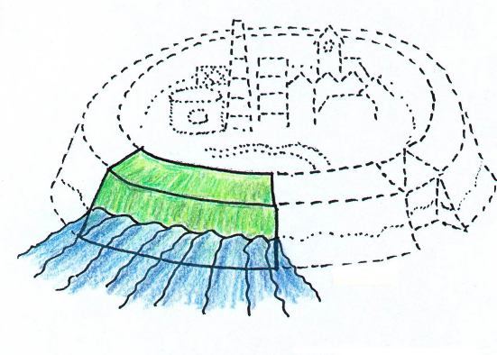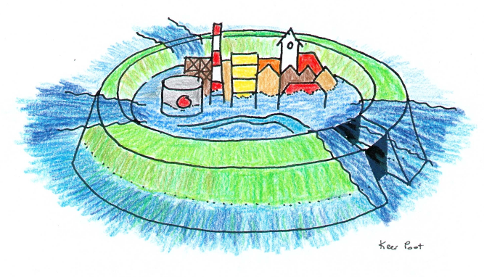
RTO-2011
2a: Detailed semi-probabilistic assessment (per mechanism and section)
1: Simple Assessment (per mechanism and section)
0: relevance check (per mechanism and section)

2b: Detailed probabilistic assessment
(for combinations of mechanisms and sections)

RTO-2017
Conservatism
Figure 1.4 RTO-2017 assessment scheme, with additional new level 2b. Level 3 (advanced) is not shown. Also not shown is the additional assessment, based on criteria defined by the regional water authority (beheerdersoordeel)

The result of a semi-probabilistic assessment is usually a certain factor of safety (FOS) per mechanism and section. A FOS is determined by the ratio between the allowed and actual value of certain load type (e.g. an overtopping discharge, a differential head for piping or a driving moment for slope instability). The result of a probabilistic analysis is an integrated failure probability (FP) for (a part of) a dike ring, which has to be compared with the allowed value. The failure probability is influenced by the uncertainty in both hydraulic loading and strength, as well as by the length and number of the sections. A probabilistic analysis for combined mechanisms and sections is always less conservative than a separate semi-probabilistic assessment per mechanism and section.

Global Assessment Work flow
Figure 1.5 depicts the global assessment work flow which is to be supported by RTO.

Flood Defences key data
(water authorities)
Safety assessment
Deterministic per section and mechanism
Probabilistic for combined sections and mechanisms

Geometry dependent schematization
Location and dimensions of the flood defence system
Flood Defence schematization

Further schematization per failure mechanism
Division in sections, with representative cross section
Simple models (less data required)
Detailed models (less conservativeness required)
Assessment results

Report results
Calculation of Hydraulic Boundary Conditions, per cross section or per output location
Water Levels And Waves

Hydrodynamic and statistical data (RWS)

Water levels and waves

Iteration loop
Figure 1.5 Work Flow Safety Assessment. RTO covers all tasks which are coloured green. The additional containers show the initial data (white) and project data (yellow). The Water authorities are responsible for delivering the flood defences key data and for executing the schematization and assessment. Rijkswaterstaat (RWS) is responsible for delivering the hydrodynamic and statistical data, and delegates the production to Deltares. The hydrodynamic data is contained in different physical databases for different regions. The project database content (flood defence schematizations, hydraulic boundary conditions, and assessment results) is coloured yellow.

Stakeholders and users

- Rijkswaterstaat is responsible for delivering the assessment tools, including the format and content of the hydrodynamic database, as well as for the data format of the schematization and assessment results and the format of the final assessment report.

- The regional water authorities (waterschappen) and Rijkswaterstaat are the end-users, responsible for the execution of the actual assessment, including data acquisition, schematization, analysis and reporting.

- The regional water authorities commission their assessment tasks mostly to specialized civil engineering consultants. The total number of consulting employees doing actual assessments is not more than two hundred.

During the RTO definition and development stage, Deltares will frequently consult the RTO Advisory Group in order to get feedback on intermediate results. This group consists of both the regional water authorities responsible for assessment and the consultants to which assessment tasks are usually delegated.

Related to the WTI as a whole, the “Directoraat-Generaal Waterstaat” is primary responsible for all formal communication with public administration representatives and the Waterdienst is primary responsible for all formal communication with the regional water authorities (in coordination with the “Directoraat-Generaal Waterstaat”). Deltares is finally responsible for communication with the civil engineering consultants (in coordination with the Waterdienst).

Failure mechanisms

A flood defence system consists of sections of dikes and/or dunes, with interjacent structures. A flood defence system can fail (meaning: lose its water retaining function) due to different failure mechanisms. An overview of relevant mechanisms for dikes is shown in Figure 1.6.
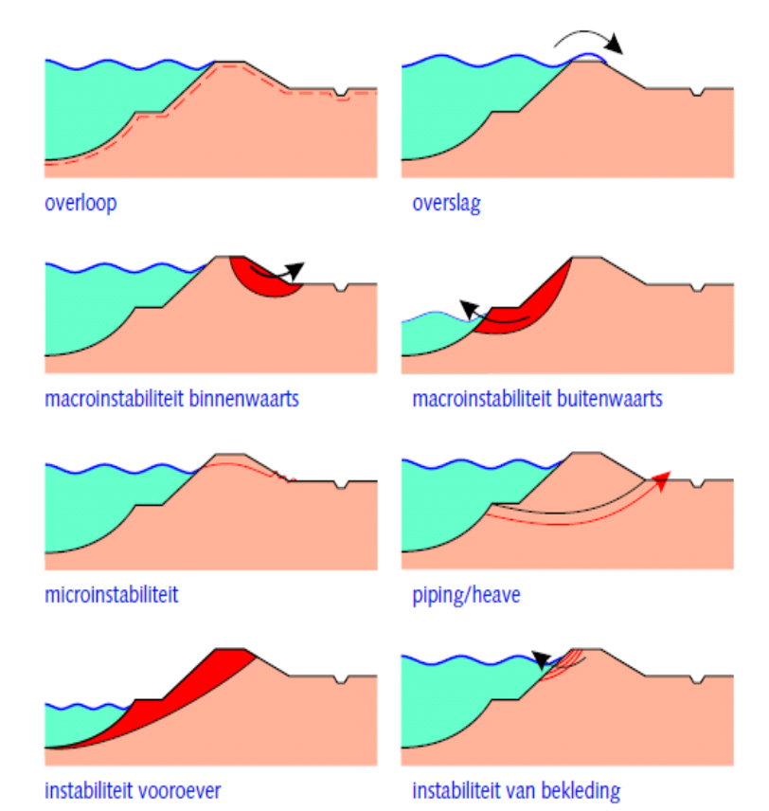
Overflow
Overtopping
Slope stability outwards
Slope stability inwards
Seepage face erosion
Liquefaction
Revetment failure
Piping (internal erosion)

Figure 1.6 Illustration of different failure mechanisms for dikes including overtopping.

Sometimes, actual failure will depend on the occurrence of more than one submechanism. An example is failure due to piping (internal erosion of sand underneath the dike or structure), which can only occur after preceding uplift of the protecting cover layer at the land side, see Figure 1.7. Another example is the failure of the inner slope due to erosion or instability, after a preceding occurrence of overtopping.
Failure due to piping
Piping (incl. heave)
Uplift
AND
Figure 1.7 Example of the fault tree for failure mechanism piping

Submechanism failure is predicted on the lowest level by cross sectional models, requiring input that is partially model specific. A cross section can contain different zones of revetment, which need to be assessed per zone.

Software architecture

Over all architecture

All tools related to RTO have a generic design. This design comes down to the general software principle to separate UI, IO and business logic. The business logic is separated into two parts, the probabilistic part and failure mechanism part. Besides these parts, there is a controller which brings together all these parts. In other words:

Each application in the collection of new generation software consists of the following four layers.

- The control layer contains the data model and steers the execution of different tasks in the three other layers.
- The User Interface (UI) layer enables presentation and manipulation of input data and results.
- The I/O-layer connects the internal or external databases to the UI layer and business layer.
- The business layer contains all functionality to derive the user-requested output from the user-supplied input.

All layers connect to libraries for the functions that are shared with one or more other applications, especially the stand-alone RTO tools.

Control layer
Failure mechanism library
Probabilistic library
I/O
UI
Business layer
External I/O files for data management, exchange and archiving
UI-library
IO library
Application 1
Application 2
Application 3
Data and I/O components (control,, read/write, convert and visualize)
Business layer components (to compute output from input)
DeltaShell Light
Figure 2.8 Generic architecture for the dike strength software

Failure mechanism considerations

The architecture focuses on two ways of using failure mechanisms, depending on the environment they are used in. These environments are:

HydraRing / Ringtoets

In this environment HydraRing (and therefore indirectly Ringtoets) invokes the failure mechanism to obtain a Z-value. A Z-value tells whether the water defence fails (Z < 0) or not (Z > 0). HydraRing will invoke the mechanism several times, each time with a slightly different input. In this way HydraRing wil be able to perform a probabilistic assessment, because HydraRing is aware of a number of input parameters for the failure mechanism with their probabilistic distributions.

One should realize that failure mechanisms are developed to calculate output based on a certain input. The Z-value does not need to be the same as the output. It is possible that there is a separate step to convert the output the the Z-value. For example, for overtopping the Z-value is calculated as dike height minus water level, but far more complex Z-value calculations are possible too.

The parameters varied by HydraRing may be a subset of the complete input of the failure mechanism. Therefore, there must be an additional way, apart from HydraRing, to feed the failure mechanism with input. It is even possible that parameters varied by HydraRing are not direct input of the failure mechanism, but must be converted to another set of data. This happens for overtopping, where HydraRing varies wind directions and forces, which must be converted to water levels and wave amplitudes by Brettschneider routines.

Finally, one should consider failure mechanisms, which calculate probabilistic design points themselves. This is the case for stability. HydraRing should be aware that a failure mechanism is able to do so, and should use the failure mechanism probabilistic output instead of varying input parameters and do a probabilistic assessment. HydraRing will use the probabilistic output to combine probabilistic results with other failure mechanisms or locations.

RTO UI-tool

An RTO-UI tools is a user interface, which allows entering of input data and viewing of output data for one failure mechanism and one location. The user interface is connected to the failure mechanism library. The failure mechanism library will calculate its output on exactly the same way as within HydraRing.

Z-values will be calculated too and therefore an indication of failure / non failure of the water defence system will be presented to the user. Note that Z-value calculations may have their own input to perform its calculation.

Input of the RTO-UI-tool comes from Ringtoets. Within Ringtoets an export can be made for a certain RTO-UI-tool, including all the input data of the failure mechanism. The export includes a distribution of the parameters to be varied, with the distribution the Ringtoets user selects. For example, the Ringtoets user may decide to export the distribution at the design point. The RTO-UI-tool user sees the data, which lead to the design point. After import, the RTO-UI-tool user may alter the input data and perform calculations. It is not possible to bring back data from the RTO-UI-tool to Ringtoets.

The user will see the same UI-components in the RTO-UI-tools as within Ringtoets, to improve recognizability and lower learning curves. Also from software development point of view, software components are to be reused, both user interface components, failure mechanisms, data models and IO-components

Failure mechanism design

Based on the considerations in the previous paragraph, we distinguish several layers in a failure mechanism. These layers are:

- Failure mechanism interface. This is the only layer known to HydraRing and handles the calculation of a Z-value based on probabilistic variations and fixed input.
- Failure mechanism layer. This layer takes care that the probabilistic variations are passed to the mechanism input.
- Z-function layer. This layer converts the mechanism output to a Z-value
- Mechanism layer. This layer performs a calculation with input and output specific for the failure mechanism.

This is visualized in the following figure. The arrows indicate the direction of data transfer.

HydraRing
Failure mechanism interface
Failure mechanism layer
Z-function layer
Mechanism layer
RTO-UI-Tool
Ringtoets
Figure 2.9 Software layers in a failure mechanism

The failure mechanism interface is the only layer known to HydraRing. HydraRing is not aware of the type of calculation behind the interface. Therefore it is implemented as a software interface. This interface is defined as follows:

public interface IFailureMechanism
{
// The probabilistic parameters
void SpecifyParameters (parameters : string[]);

// Computes Z based on varied parameter values
double[] ComputeZ (values : double[][]);
}
An instance of this interface implements piping, overtopping or another failure mechanism. Besides this interface this instance has also methods to specify the fixed input, such as allowed overtopping volume. These additional methods are known to Ringtoets, but not to HydraRing. The interface for overtopping will have at least the following output variables:
{
real () :: z_Runup_2percent !< wave runup 2%
real () :: q_overtopping !< overtopping discharge
}

The interface allows requests of Z-values for several variations on the input data at once. It is up to the failure mechanism how to calculate them, sequentially, in parallel or distributed over several machines. The Z-function for Overtopping header is defined as follows:

subroutine zFuncOvertopping ( x, z )

real(kind=wp), intent(inout) :: x(*) !< x values
real(kind=wp), intent(out) :: z !< z value

type(tpOvertoppingPCOGeometry) :: geometryPCO
type(tpOvertoppingPCOLoad) :: loadPCO
type(tpModelFactorsOvertopping) :: modelFactorsPCO
...
end subroutine

The failure mechanism layer merges the probabilistic varied data into the full mechanism input. The full mechanism input contains all data needed to perform a calculation. These data consists of the following parts:

- Data specific for the mechanism, such as the internal model options to be used
- Non probabilistic data specific for the location, such as the dike height
- Probabilistic data for the location. However, per calculation a fixed value is dictated by HydraRing

These data are input for the Z-function by the input variables modelFactorsPCO, geometryPCO and loadPCO.

1. Mechanism specific model parameters (var: modelFactorsPCO):
type, public :: tpModelFactorsOvertopping
real (kind=wp) :: waveRunup1 !< Model factor1 for wave runup
real (kind=wp) :: waveRunup2 !< Model factor2 for wave runup
real (kind=wp) :: waveRunup3 !< Model factor3 for wave runup
real (kind=wp) :: boundBreaker1 !< Model factor1 for boundary of the
breaker parameter
real (kind=wp) :: boundBreaker2 !< Model factor2 for boundary of the
breaker parameter
real (kind=wp) :: boundBreaker3 !< Model factor3 for boundary of the
breaker parameter
end type

2. Non-probabilistic data, e.g. dike geometry* (var: geometryPCO)
type, public :: tpovertoppingPCOGeometry
real (kind=wp) :: ht !< level (height) of the toe of the dike
real (kind=wp) :: hBerm !< level (height) of berm
real (kind=wp) :: hk !< level (height) of the outer crest line
(buitenkruinlijn)
real (kind=wp) :: deltaBerm !< height difference of berm
real (kind=wp) :: b !< length of the berm
real (kind=wp) :: tanAlphaOutAbove !< tangent angle outerslope above
the berm
real (kind=wp) :: tanAlphaOutBelow !< tangent angle outerslope below
the berm
real (kind=wp) :: tanAlphaIn !< tangent angle of the inner slope
real (kind=wp) :: psi !< normal of the dike
real (kind=wp) :: dk !< width of the protective clay layer
real (kind=wp) :: cg !< erosion resistance of the grass layer
real (kind=wp) :: kUO !< roughness of the talud (outerslope)
real (kind=wp) :: kIN !< roughness of the talud (inner slope)
end type

* This list needs to be modified with Functional Design Overtopping Mechanism updates.

3. Probabilistic data, fixed per location e.g. hydraulic boundary (var: loadPCO)
type, public :: tpOvertoppingPCRingLoad
real (kind=wp) :: Hs !< wave height
real (kind=wp) :: Tm_1 !< spectral wave period
real (kind=wp) :: h !< local waterlevel
real (kind=wp) :: phi !< wind direction
real (kind=wp) :: ts !< storm duration
real (kind=wp) :: Pt !< time period that overtopping/overflow occurs

This dataset can be exported from Ringtoets to an RTO-UI-Tool through an xml file. Although Ringtoets can handle several locations, the export will contain only one location. The export includes the dictated values for probabilistic parameters, hence allowing recalculating the design point.

The failure mechanism layer is responsible for conversion to appropriate data. For example, conversions like Brettschneider are to be performed here.

The RTO-UI-tool is aware of the mechanism layer and the Z-function layer. In the tool the user can modify the input and do calculations.

The complete input dataset is also provided to the mechanism layer. The mechanism will compute an output based on this input data set. The mechanism will also provide progress information, always as a vaule between 0 and 1. To let the world know about its progress, a method (delegate) is provided to the mechanism. In case of running under HydraRing, this method will be provided by HydraRing. In this way HydraRing can convert this information into an overall progress of the probabilistic assessment. When running under an RTO-UI-tool, the progress will be presented to the user as a progress bar.

The mechanism layer will also produce log messages, i.e. messages important for the user to know, for example failures and recoverages within the mechanism. They will be handled in a similar way as progress information. All mechanisms share the same definition of progress delegate and log message delegate.

When an error occurs in a failure mechanism whilch cannot be handled, an exception is thrown. This will stop the HydraRing assessment. On user interface level the error will be handled (the user will be informed).

Each calculation therefore will implement a standardized software interface, containing methods to set the progress and log messages delegate and a method to perform the calculation. This interface is defined as follows:

public interface ICalculation
{
// Sets the progress delegate
void SetProgressDelegate (progress : ProgressDelegate);

// Sets the progress delegate
void SetMessagesDelegate (messages : MessagesDelegate);

// Runs the calculation and possibly raises exceptions
// The project object contains all input
// It will be enhanced with results by the calculation
void Run (project : object);
}

Version information about the calculation can be retrieved by accessing the assembly where the calculation is defined.

Programming language issues

HydraRing and possibly part of the mechanism layer is programmed in Fortran, all other software in a .net compliant language, mostly C#. Because a failure mechanism is accessed both from the .net environment (Ringtoets, RTO-UI-Tools) and from Fortran, the failure mechanism itself is programmed in C#. To enable the Fortran part (HydraRing) to make calls to it, the ComputeZ method in the failure mechanism is passed as a delegate to HydraRing.

Because a delegate is used, it is not necessary to pass the non probabilistic input of the failure mechanism through the HydraRing layer. It will be present in the class instance which provides the delegate, but has more information than just the delegate. It will also contain all other relevant data for the failure mechanism.

From outside, a failure mechanism provides a .Net interface. Possibly this is a wrapper around a Fortran calculation core, but not necessariliy so. The internal Fortran part is not reachable from outside. Therefore standard C# ways are used to invoke Fortran code.

Data model
Most part of the mechanism layer is written in Fortran code. A C# layer around the Fortran code will act like a wrapper. The wrapper makes the mechanism layer accessible by the user interfaces Ringtoets and RTO-UI-Tools as stated in the previous section. Function calls from those interaces use data classes. Data classes can have complex structures which are not supported in Fortran. In Fortran only basic, low level data structures can be defined (real, integers, etc.). A conversion between the complex data classes (C#) and the Fortran tables is therefore necessary.

The table below gives the translation of the data classes from the Overtopping module to Fortran variables. The variable names can be adapted during the development periods.

Ringtoets Data class | Fortran variable
(DeltaModel)  SurfaceLine | [dikeprofile]
(DeltaModel)  SchematizedSurfaceLine -> | [schematized profile]  [x,z-points table]
CharacteristicPoint ->  GeometryPoint:  X,Y,Z, : double | tpovertoppingPCOGeometry:  ht [level (height) of the toe of the dike]  hBerm [level (height) of berm]  hk [level (height) of the outer crest line (buitenkruinlijn)]  deltaBerm [height difference of berm]  b [length of the berm]  tanAlphaOutAbove [tangent angle outerslope above the berm]  tanAlphaOutBelow [tangent angle outerslope below the berm]  tanAlphaIn [tangent angle of the inner slope]  dk [width of the protective clay layer]
(SoilProfile)  Revetment ->  [Roughness] | kUO [rougness of the talud (outerslope)]
(DeltaModel)  SurfaceLine ->  Angle | tpovertoppingPCOGeometry:  psi [normal of the dike]
(DeltaModel)  WaterLevel | h [water level]
(DeltaModel)  Wave | Hs [wave height]  Tm_1 [spectral wave period]  phi [wind direction]
(AssessmentModel)  OvertoppingMechanism ->  AllowedOvertoppingVolume | [q_critic]

User interface design

The Ringtoets UI an IO layers will be based on the Delta Shell Light library of software components, with a standardized look and feel. Delta Shell Light is a C# framework developed by Deltares and already used in different applications (DAM, D-SoilModel, Koswat, D-GeoStability and Ringtoets).

The main philosophy behind the design of the Delta Shell Light components is that a user should be able to start with execution of his tasks without a steep learning curve. To accomplish this, the UI based on Delta Shell Light has the following features.

- A cross section editor is placed centrally in the application.
- Besides the cross section editor, there are a couple of windows. Each window has its own way of presenting data. For example, there is a table section which displays data in tabular form. The same data can be presented on the map and/or a cross section. The following windows are available in Delta Shell Light:

Window | Description
Cross section window | Displays a cross section of the vertically arranged data in two dimensions, for example a sub soil cross section. The cross section editor supports layers and has a legend.
Property window | Displays properties of a certain object, for example the selected object on the map or in a table. Depending on the type of object, there may be a different way of presentation. For example, a dike ring might contain a table of dike sections, a soil might have a long list with properties and a Q-h relation might display a small diagram.
List and chart section | Contains several tables and charts. All data which can be presented in a table can be displayed here. Also charts can be displayed, with or without connection with a table.
Feedback section | Gives the user feedback about the data he has entered. This can be information about the validity of data or suggestions about which task to perform. For example, a message is displayed if a value exceeds the maximum allowed value. The suggested resolution is to assign the maximum allowed value, which will be performed on user request. The user will be able to start a calculation if all error messages have been resolved.  The data model containing all business data, containing input for calculations, also contains methods to validate the input. The validation is invoked automatically on data changes and runs in a separate thread.
Output section | The output section is to be used for display of messages generated by a calculation. The contents are purely informative for the user.

Figure 2.10 displays an example of a user interface based on Delta-Shell Light. This example shows that a map display, a cross section display, a property window, a table section and a feedback section are used.

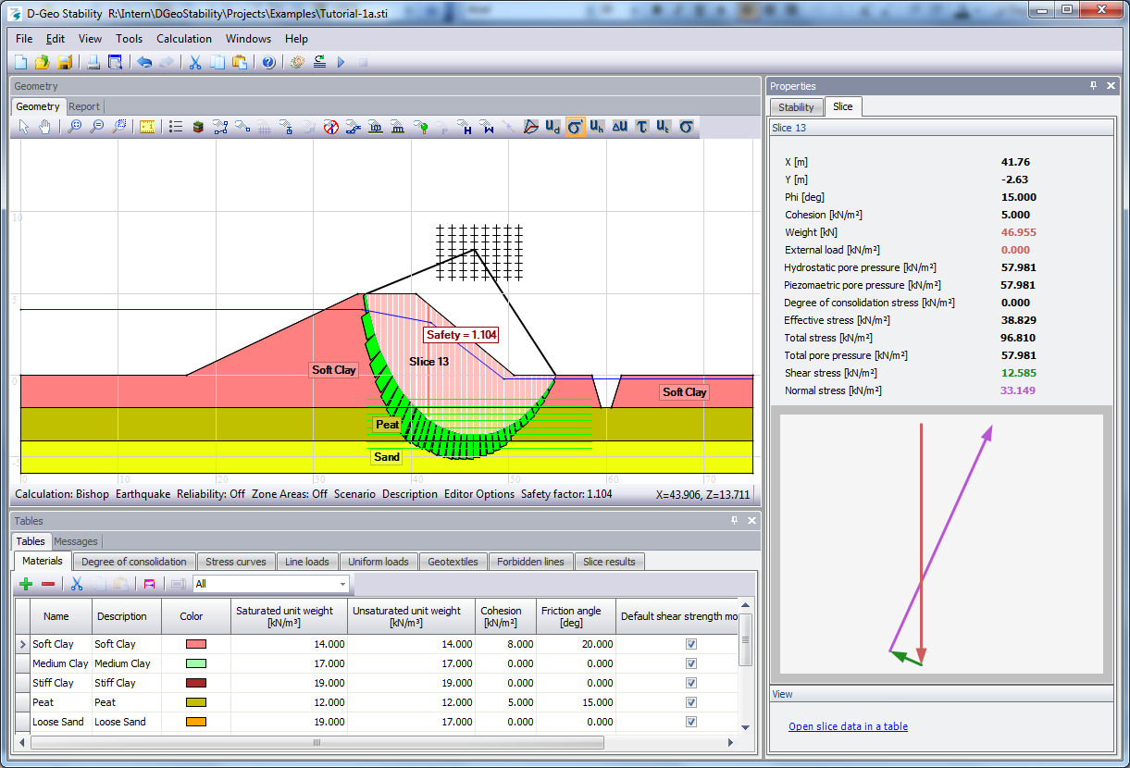
Figure 2.10 Example of an User Interface based on Delta Shell Light

The following generic features are provided as part of the different Delta-Shell Light components.

Feature | Description
Multi language support | The application can be displayed in multiple languages
Multi unit support | The application can be displayed with different units. In this way the user can select units appropriate to the size of values or what he is familiar with.
Track changes | The application keeps track the original data source of data and whether it has been modified by the user.
Startup behaviour | The application can be configured what to do on startup, load a new project or load the last used project.
Selection behaviour | The selected object is synchronized among all windows. This helps the user to understand what is displayed in all windows. For example: the map window, cross section, property window and table section all display the same selection of a certain object.

Delta-Shell Light uses C# components of the DevExpress and DotSpatial libraries. These libraries contain many different components for editing, visualization, reporting and exporting. Delta-Shell Light uses these features to create applications with a standardized look-and-feel.

Toolkit | Description
DotSpatial components | Display a map; open shapefiles/grids/rasters and images in a map; render and reproject map data etc.
DevExpress components | Various UI components : navigation pane, editors, grids, tree lists, ribbon bars, reports and charts, printing and exporting in various formats (HTML, PDF, XLS, CSV ) etc

The cross section editor displays a comprehensive view of the dike location. All data which have a This section describes the functionality of the cross section editor in detail. The purpose of the cross section editor is to provide a comprehensive view of data defined at a dike section. The data will be visualized in the LZ plane. Only data which can be visualized in this plane will be displayed, for example sub soil data, a surface line, water level, etc., but not computational settings.

The figure below schematically displays the cross section editor:

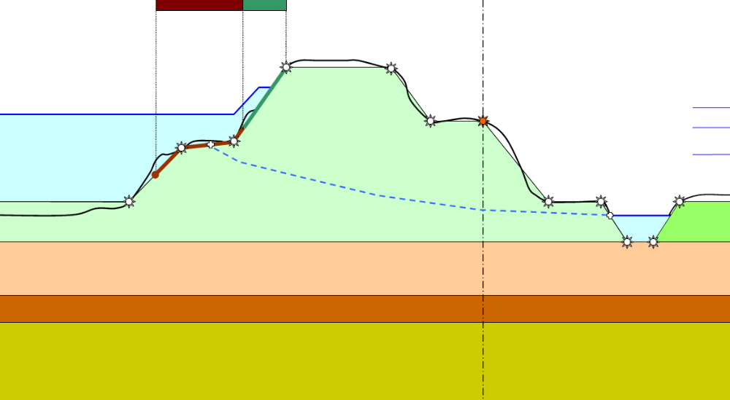
Figure 2.11 Modifying characteristic points along surface line in dike cross section editor

Glossary of terms
(Terms in italic are not used in the current report)
English |  | Dutch |  | Description
APT |  | APT |  | Arbitrary point in time – refers to a alternative method for FBC, modelling the time position in a trapezoidal shaped evolution of a discharge wave or lake level by using an additional stochastic time variable.
Assessment |  | Toets |  | refers to the assessment of flood defences to determine if they comply with legally mandated protection levels during the assessment period
Assessment water level |  | Toetspeil |  | Characteristic water level associated with a legally mandated exceeding probability at the end of the assessment period.
Block |  | Blok |  | Refers within the FBC calculation scheme to the rectangular shape of a temporal process, such as a discharge wave.
Block duration |  | Blokduur |  | The width (in time) of a temporal process represented by a block
Central form |  | Centrale dialoog |  | The central form of the program screen.
Characteristic lines |  | Karakteristieke lijnen |  | Lines parallel to the dike, which combine a certain characteristic point in different dike cross sections.
Characteristic value |  | Karakteristieke waarde |  | Value with a certain exceedance probability
Combining |  | Oprollen |  | Combining failure probabilities for elements with unequal design points, using the Hohenbichler method
Combination sections |  | Combinatie vakken |  | Dike sections, with a division following from the joined mechanism sections, for a semi-probabilistic assessment of combined mechanisms
Cross section |  | Doorsnede |  | A dike cross section
D |  | Dagenlijn |  | D(Q). The average number of days per winter period that the discharge Q exceeds a certain value
DAM |  | DAM |  | Dike strength Analysis Module, for automated schematization, analysis and design, based on geotechnical failure mechanisms.
Design point |  | Illustratiepunt /Ontwerppunt |  | The combination of parameters at failure with the highest probability. The FORM method linearizes the Limit State function in this point, after estimating it by a gradient search method.
Design water level |  | MHW, Ontwerppeil |  | Characteristic water level associated with a legally mandated exceeding probability at the end of the design life
Detailed assessment |  | Gedetailleerde toetsing |  | A semi-probabilistic or probabilistic assessment (level 2a or level 2b), based on failure mechanism models requiring detailed input.
Dike |  | Dijk |  | A dike as part of a defence system.
Dike line |  | Dijk lijn |  | The dike location line, usually connecting the points at the approximate centre of the dike crest.
Dike point |  | Dijkpunt |  | Point on dike line marking the begin/end point of a dike section.
Dike ring |  | Dijkring |  | A dike ring is a continuous line of flood defences (dikes, dunes, structures, barriers or high ground), protecting a certain region.
Dike section |  | Dijkvak |  | A part of the dike for which strength and load properties are homogeneous
Discharge |  | afvoerdebiet |  | The river discharge Q
Discharge peak |  | Afvoerpiek |  | The highest discharge in a modelled discharge wave
Discharge wave |  | Afvoergolf |  | The assumed development in time of the river discharge during a high water period.
Drop down menu |  | Drop down menu |  | A drop down menu with a number of predefined selection options.
DS |  | Directional Sampling |  | Monte carlo directional sampling
Dune |  | Duin |  | Dune as part of a defence system.
Discharge exceedance frequency curve |  | Werklijn, Frequentielijn |  | F(Q).The average number of occurrences per winter period that the discharge Q exceeds a certain value
Failure Mechanism |  | Faalmechanisme |  | A fundamental process or defect causing failure of the water retaining function. Examples are: oveRTOpping/overflow, slope instability, piping, revetment failure, dune erosion etc.
Failure mechanism model |  | Faalmechanisme model |  | A failure mechanism can have more failure mechanism models. The failure mechanism piping can have one or more sub soil models.
Failure probability (FP) |  | Faalkans |  | The annual probability that a flood defence fails, i.e. that water enters the protected area.
FBC |  | FBC |  | calculation scheme named after Ferry, Borges and Castanheta, with a blockwise description of the temporal evalution of a discharge wave or lake level..
Fetch area |  | Strijklengte |  | The fetch area per wind direction for the development of wind waves according to the Bretschneider model.
File format |  | Bestandsformaat |  | File formats are defined for specific data sets.
Flood defence |  | Waterkering |  | A water retaining object (dike, dune, structure), protecting the hinterland.
Foreland |  | Voorland |  | Area outside the dike, from dike toe to (hydraulic boundary) point with undisturbed hydraulic conditions.
FORM |  | FORM |  | Probabilistic method: First Order Reliability Method, determines the so-called design point and associated FP using iterative linearization of the limit state function
FOS |  | Veiligheidsfactor |  | Factor of Safety. Ratio between allowed and actual value of a certain load type.
FP budget |  | Faalkansenbudget |  | The allocated allowed failure probability for different mechanisms and sections, in case of a sem-probabilistic assessment
GIS |  | GIS |  | Geographic Information System
GIS-layer |  | GIS kaartlaag |  | Layers in a GIS map of a certain theme.
GIS-map |  | GIS kaart |  | A map with geographic background and objects.
Heave |  | Opbarsten |  | Mechanism of heave of the cover layer, due to the upward pore pressure in the aquifer underneath .
Hydraulic load |  | Hydraulische belasting |  | Load of a construction due to hydrodynamic processes.
Hydrodynamic database |  | Hydraulische randvoorwaarden |  | Database with the hydrodynamic parameters.
Key data |  | kerngegevens |  | Key data, for setting up a dike schematisation. Most key data will be imported from existing databases, maintained by the water boards.
Length effect |  | Lengte effect |  | The increase in failure probability that results from considering longer stretches of dike (or dunes)
Limit State Function (LSF) |  | LSF |  | Describes the interface between failure and non-failure for different combinations of stochastic parameters
Loop sequence |  | Rekenschema |  | Refers to the sequence of loops (e.g. over time periods, wind directions and mechanisms) in programming code
MC-C |  | MC-C |  | Probabilistic method: Crude Monte Carlo sampling.
MC-IS |  | MC-IS |  | Probabilistic method: Monte Carlo importance sampling
Mechanism |  | mechanisme |  | see Failure mechanism
Mechanism section | Mechanismevak |  | A stretch of a flood defence with more or less homogeneous properties and boundary conditions for the considered mechanism.
Menu bar |  | Menubalk
N |  | Overschrijdingsduurlijn |  | Duration line. N(Q) = D(Q)/F(Q). The average duration of the period in which Q exceeds a certain value
Navigation pane |  | Navigatie paneel |  | Navigation pane with lists of editable GIS-objects such as cross sections, dike line and hydraulic boundary points.
NTI |  | Numerieke tijdsintegratie |  | Refers to a method for modelling the shape of a temporal evolution of a discharge wave or lake level, by discretizing it into sections of width Δt, and combining the failure probability contributions of all sections. The combination of NTI with NI gives characteristic water levels equal to the Hydra’s.
NI |  | Numerieke integratie |  | Probabilistic method: Numerical Integration. Discretizes random variables and for each combination computes the probability of occurrence and subsequently sums over all combinations that led to failure
Overflow |  | Overloop |  | failure mechanism that occurs when the water level is higher than the crest height of the defence
OveRTOpping |  | Overslag |  | failure mechanism that occurs when the waves run over the crest height of the defence (water level + wave > crest height)
Piping |  | Piping |  | The mechanism that causes loss of stability by internal erosion
Presentation section |  | Presentatievak |  | Sections consisting of one or more combination sections, for the purpose of presenting the combined contribution from different mechanisms in case of a probabilistic analysis.
Probabilistic analysis |  | Probabilistische analyse |  | Probabilistic determination of failure probabilily, using stochastically distributed variables for loading and strength.
Project database |  | Project database |  | Database with all project data, except for the results database and hydrodynamic database of the active project.
Relevance check |  | Relevantie toets |  | Relevance check for a certain failure mechanism for a certain dike section (level 0).
Revetment |  | Bekleding |  | Revetment of a dike, defined by different zones, each consisting of a certain revetment type with associated properties.
Screen |  | Beeldscherm |  | The screen user interface of the RTO application.
Semi-probabilistic analysis |  | Semi-probabilistische toets |  | A deterministic assessment (level 1 or 2a), using conservative characteristic values for loading and strength parameters, together with partial safety factors. The safety factors are calibrated such, that the failure probability will always stay below the allowed value.
Section |  | vak |  | Part of the flood defence system with more or less homogeneous loading and strength properties.
Simple assessment |  | Eenvoudig toetsing |  | Simple assessment of a dike section (level 1), using failure mechanism models requiring only geometrical data.
Slope instability |  | Macro-instabiliteit |  | The mechanism that causes slope shear failure of dike embankments
Structures |  | Kunstwerken |  | Civil structures build as part of the defence system.
Sub-mechanism |  | Deelmechanisme |  | A submechanism which only causes failure when combined together with another submechanism
Subsoil |  | Ondergrond |  | Subsoil of the dike’s basement.
Subsoil profile |  | Ondergrondprofiel |  | A sequence of subsoil layers, either 1D or 2D.
Subsoil scenario | Ondergrondscenario |  | A subsoil profile with certain occurrence probability, in case of stochastic subsoil modelling.
Surface line |  | Dijkoppervlak |  | The surface line of the dike in the cross section, including the relevant part of the waterbed and the hinterland.
System Architecture |  | Systeemarchitectuur |  | The hardware design of an application.
Tab |  | Tabblad |  | Tabs are used to switch between different forms.
Tidal period |  | Getijperiode |  | A period of (approximately) one tide, relevant in the load modelling for an arbitrary discharge wave shape
Upscaling |  | Opschalen |  | Combining failure probabilities for a number of elements (time elements or spatial elements) with equal FP
XML |  | XML |  | Self describing data format, suited for exchange through files or web-services

Data classes
This section describes the data classes as designed for Ringtoets. They are in common with RTO-UI-Tools

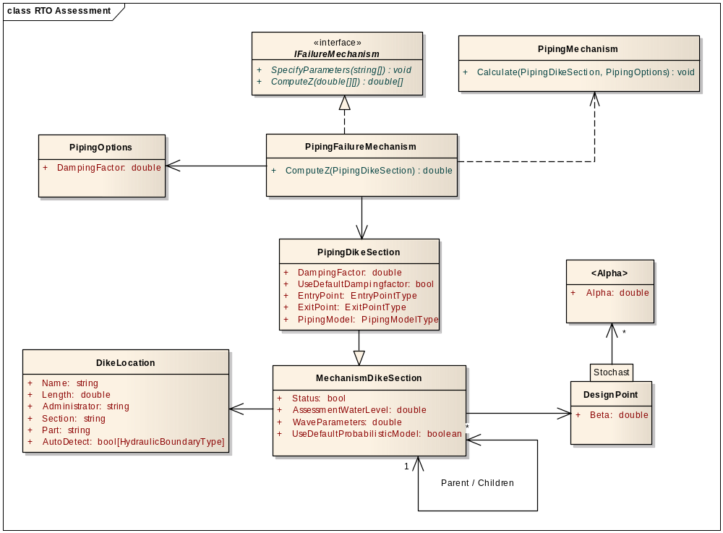
Figure 2.12 Data Classes failure mechanisms.

Only piping is used as an example. Other failure mechanisms have similar constructions. The classes have the following meaning:

Class | Description
IFailureMechanism | General interface for models capable of being assessed in a probabilistic way. The probabilistic library is aware only of this interface.
  SpecifyParameters | Specifies which and the order of the parameters, which will be varied by the ComputeZ call.
  ComputeZ | Requests for the calculation of Z-values for sets of varied input data.
PipingOptions | Default options or options on mechanism level for piping.
PipingFailureMechanism | Implements IFailureMechanism. Delegates deterministic calculations to the PipingMechanism.  When Ringtoets exports data to RTO-UI-Tools, an instance of PipingfailureMechanism will be serialized.
PipingMechanism | Calculates a deterministic piping calculation. Output is written to the piping dike section
PIpingDikeSection | Contains all piping information specified on location level
MechanismDikeSection | More generic data for a dike section
DikeLocation | All input data of a dike location
DesignPoint | Indicates the failure probability, over all (Beta) and distinguished per stochastic parameter.

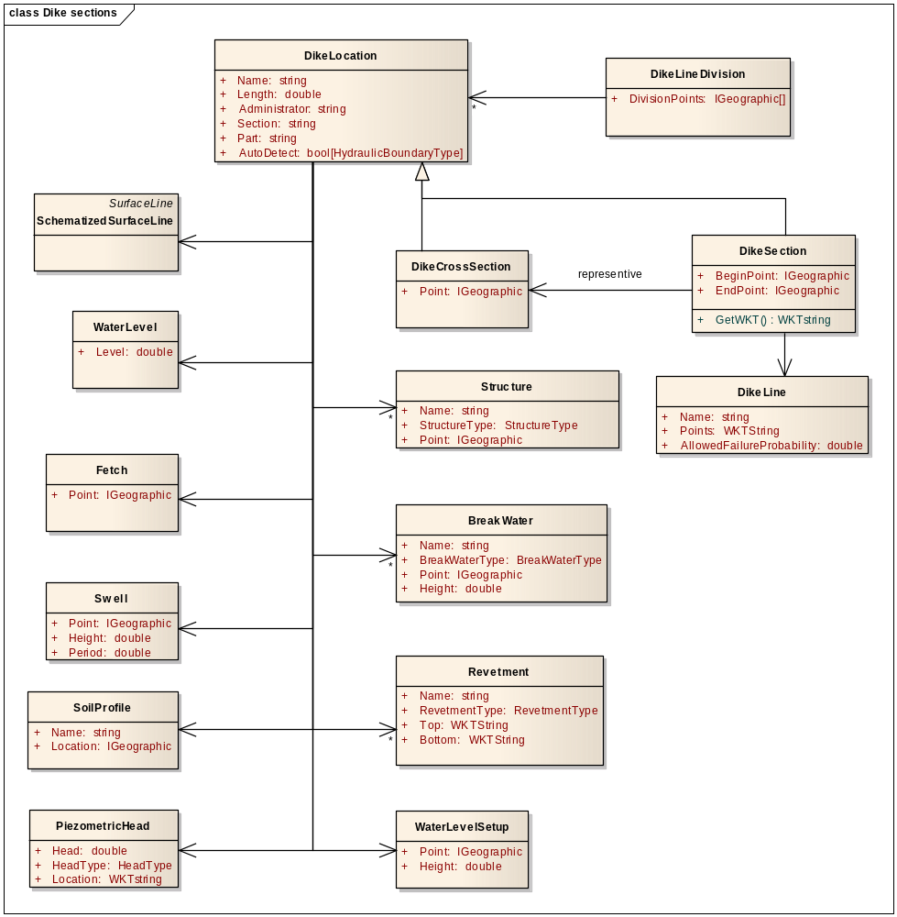
Figure 2.13 Data Classes for Dike location.

The classes have the following meaning:

Class | Description
DikeLine | A dike line is a ‘backbone’ of a dike and applicable for all failure mechanisms. The user can select points along the dike line to view properties such as a name.  Points have global XYZ-coordinates and local L-coordinates along dike line. Locations can have name (labels) or L-coordinate indications (km-pole)  NL: naam locatie, km-palen
CharacteristicLine | Line of points of the same characteristic type. These points are used to derive the characteristic points per schematized surface line. The Characterstic points are the intersections of characterstic lines with SurfaceLines.
Fetch | Fetch area. The incoming angle is relative to the dike normal (perpendicular to dike line)
WindFetch | Fetch data per wind direction
FetchLength | Fetch data per wind direction and layer
Revetment | Revetment zones are visible in the map editor and cross section editor. Revetment zones are defined by two paths in the horizontal plane, indicating the left and right border of the revetment zone. The distance is related to crest axis. Such a path is expected to be close to the dike line, but not necessariliy so. A path is a line consisiting of points.  The actual top and bottom at a certain location become clear in combination with a (schematized) surface line (intersections revetement paths with surface line). The user can select, add, edit and remove revetment zones.  Revetment types: grass, stone, asphalt, with sub-types. Revetment has physical revetment properties such as size and parameters for mechanism models. The model parameters are different per revetment type and sub-type. Inpuft for each property the mean value, statistical standard deviation and standard deviation used for mechanism.  There can be more than one revetment zones in one cross section (profile sections or revetment zone sections on the surface line).  NL: Bekledingszone, zonenaam, bekledingstype (gras, steen, asfalt met onderverdelingen), onder en bovengrens zone, bekledingseigenschappen (afmetingen, faalmechanisme specifieke parameters).
Structure | Hydraulic Structures like gates, concrete defense walls, etc  Structurs are line objects and have a begin and endpoint (location points). Their line symbology in the map is different from the dike. They have a name, type, geometry, and other assessmemt specific properties.  NL: kunstwerk; verticale muren. Eigenschappen: naam, type, afmetingen, overige eigenschappen voor toetsing.
Breakwater | Breakwaters like dam caisson, rubble mound, are line objects. They have a begin and end point (location points). The structures have a symbology that is different from the dike line. (e.g. line width, colour) in the map editor. The user can select a the structure and open its project property form for: name, type, geometry and other assessment specific properties.  NL: dam, caisson, strekdam.  NL: eigenschappen: naam, type, afmetingen, overige eigenschappen voor toetsing.
PiezometricHead | Piezometric Head is imported with key-data in the map editor as polygons. It is applied to all cross sections inside a particular polygon. Cross sections outside the polygon will need additional, manual input of the Piezometric head in the cross section editor.
PolderLevel | Water level at the polder side, to be used as water level in a ditch on the polder side.  NL: polderpeil.
WaterLevelSetup | User defined water level setup value per wind direction. NL: opzethoogte, windrichtingsector.
Swell | Wave parameters due to swell, no user data.  NL: deining, golfhoogte, golfperiode.
WaterLevel | Water level at dike toe at the river side (if available).
Wave | Wave data at dike toe. Properties are peak period and angle, i.e. angle of attack onto dike
Seiche | Defines a seiche, i.e. a long standing wave
DikeLineDivision | Definition of a division of dike into sections. Note that soil model doesn’t refer to this class. It will be used by the assessment model.  NL: vakindeling dijklijn, mechanisme vakken.
DikeLocation | Location or stretch along a dike
DikeCrossSection | Cross section which is used at level 0 and 1. The location coincides with a schematized surface line. Cross sections have (default) names.
DikeSection | Dike section which is defined as a stretch along a dike and using the key and hydraulic boundary data from a representive DikeCrossSection

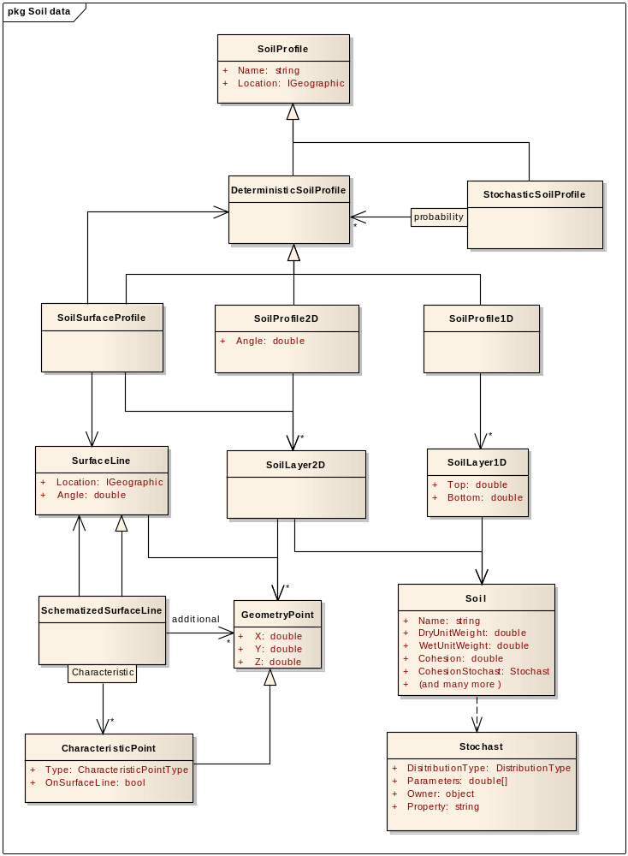
Figure 2.14 Data Classes for subsoil key data

The classes have the following meaning:

Class | Description
SoilProfile | Defines the appearance of a soil at a location.
DeterministicSoilProfile | Soil profile which defines the appearance of a soil in a deterministic way, this means it is exactly defined which soil is present at which location.
StochasticSoilProfile | Collection of deterministic soil profiles, with each soil profile having a certain probability
SoilProfile1D | Describes a sub soil divided in horizontal layers
SoilLayer1D | Horizontal layer of a soil, with indication of top and bottom level resulting in layer thickness and layer position. The bottom level is always equal to the top level of the underlying soil layer.  Piping indication (upper subsoil layer, shallow aquifer at dike, shallow aquifer next to dike, second deep aquifer).  NL: naam, ligging bovenkant (laagdikten), type voor piping (deklaag, ondiepe watervoerende laag onder de dijk, ondiepe watervoerende laag buiten de dijk, tweede diepe watervoerende laag), ligging, laagdikte.
Soil | Contains all soil properties, such as mass density (dry and wet), piping parameters (e.g. erosion resistance top layer, damping factor, is aquifer or aquitard) and stability parameters.  NL: soortelijke dichtheid, parameters voor pipingmodel, bijv. erosiebestendigheid toplaag, weerstandscoëfficiënt onderlaag (afhankelijk van ligging). Stabiliteits parameters.
SoilProfile2D | Describes a sub soil, where the appearance of the soil depends on the horizontal coordinate
SoilLayer2D | Describes a 2D layer, i.e. the thickness and position of the soil depends on the horizontal coordinate. One can think of a polygon indicating the position of the soil.  Piping indication (upper subsoil layer, shallow aquifer at dike, shallow aquifer next to dike, second deep aquifer).  NL: naam,
SoilSurfaceProfile | Soil profile which consists of a deterministic soil profile and a surface line. The surface line truncates the soil profile from the air.
SurfaceLine | The surface line is a collection of points on the surface in such a way that it describes the contour of the dike. Usually the points are collected from DTM and corrected for riverbed and ditch. The points are supposed to be perpendicular to the dike line. The surface line has a surface line location, which is a point in RD coordinates, and an angle, which indicates the angle of the line with surface points with the RD latitude. The points are defined with relative coordinates to the surface line location and angle (X is distance to surface location, Y is zero, Z is real depth)
SchematizedSurfaceLine | A surface line which is based on a surface line, but modified in such a way that it can be used by a failure model. This includes the definition of a number of characteristic points and possibly some additional bending points on the surface.
CharacteristicPoint | Characteristic lines run parallel to the dike line and are imported as key-data. In the cross section editor the lines are visible as characteristic points at intersections with the surface line. The user can select, move, add and delete these characteristic points. Adding and moving is only possible along the surface line. Characteristic points must be labeled as: begin point fore land, entrance point piping, toe outer slope, outer crest, crest, inner crest, inner slope, toe inner slope, start ditch, end ditch, etc.  NL: karakteristieke punte op dijkprofiel: begin voorland, intreepunt (piping), teen buitenberm, buitenteen, buitenkruin, kruin, binnenkruin, binnenteen, teen binnenberm, start sloot, eind sloot, enz.
GeometryPoint | 3D Point, which indicates a point in a surface line. The X and Y coordinates indicate the geographic location, but defined relatively to the location of the surface line.
Stochast | Defines the stochastic distribution of a property in, for example, soil. The distribution type and parameters define the stochastic values. The number of values depend on the distribution type. The following distribution types exist: Deterministic (1 value), Normal (2), LogNormal (3), Uniform (2)  For each stochastic parameter there is an associated property in a class, for example DryUnitWeight stochastic parameter is associated with the DryUnitWeight base property (being a double) in the soil class. This is defined by the owner and property in this class.

Notes on requirements
The following notes on requirements are made:

Requirement | Note
19/20/24 | Implicitly by using .Net class libraries
23 | C# or C# wrapper around Fortran
25 | No, exceptions will be used
27 | Is part of the documentation
31 | Validation is not part of a calculation. This is invoked from the UI
32 | Is part of the input
31/33 | Object is passed instead of simple array types or xml string

A delegate is a pointer to a method of an instance of a class

